NEW JERSEY ARBORISTS
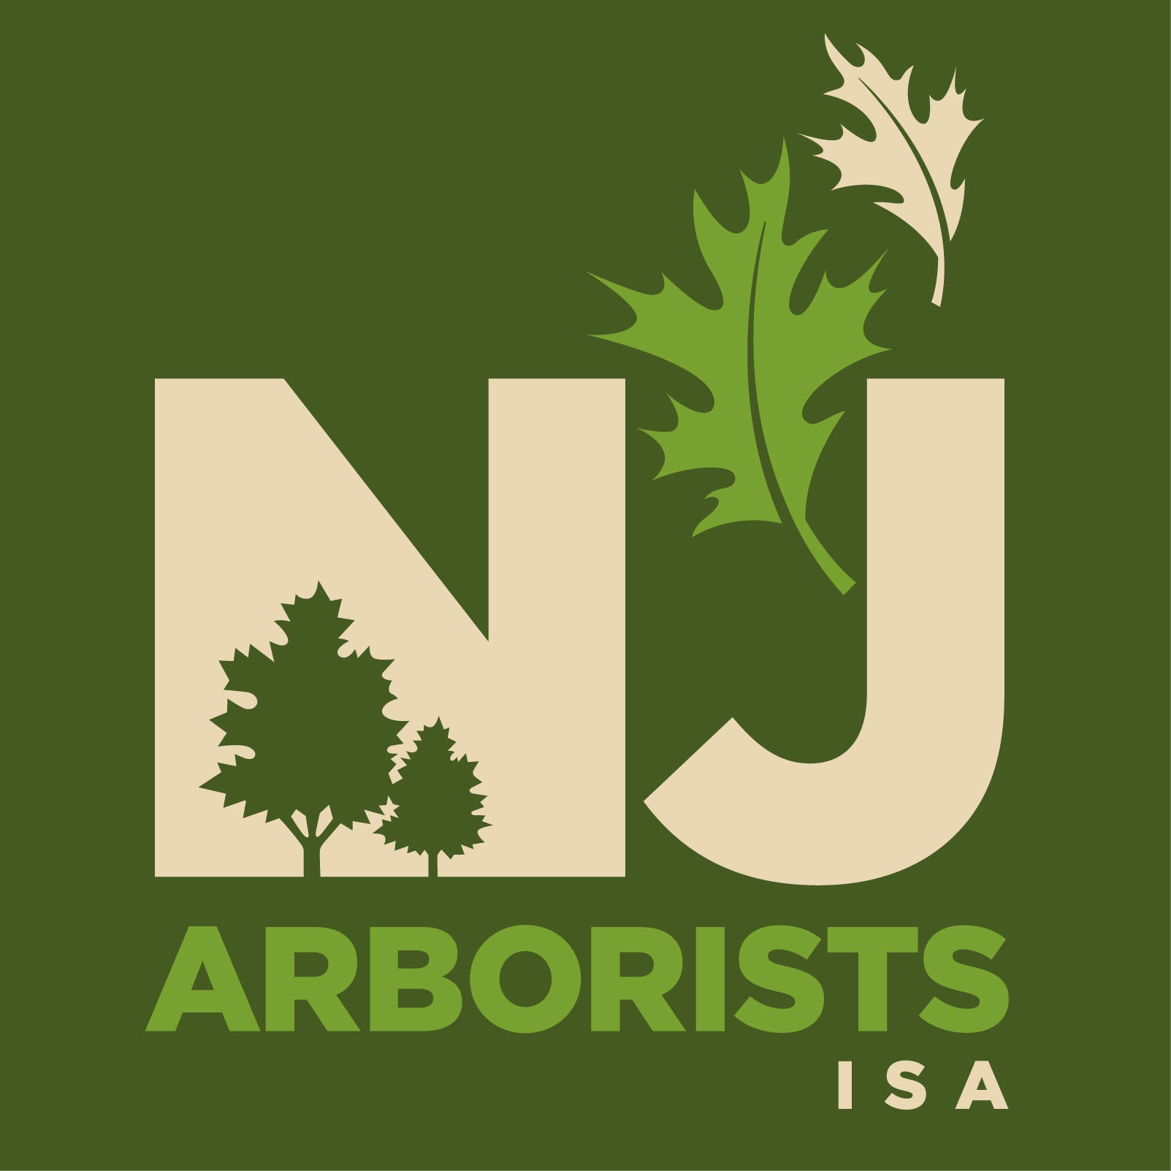
INTERNATIONAL SOCIETY OF
ARBORICULTURE

PRESENTS THE

2017 TREE Fund Golf Outing
PEBBLE CREEK COUNTRY CLUB
40 Route 537 East, Colts Neck, NJ
Tuesday, October 3, 2017
Registration & Breakfast 7:30 – 8:30 am / Lunch 2:30 pm
Shotgun starts at 9:00 am!
We once again invite you to join us at the annual NJAISA Golf Outing, held this year at this new location: PEBBLE CREEK COUNTRY CLUB in Colts Neck, NJ. This picturesque 18-hole championship golf course was designed by legendary course architect Hal Purdy, Pebble Creek Golf Club provides golfers with an enjoyable and memorable experience. The unique characteristics and differing landscapes of each hole present a challenge for accomplished players while remaining player-friendly for beginners. This year’s proceeds will benefit our bi-annual chapter challenge goal for the Tree Research and Education Endowment (TREE) Fund. The TREE Fund has become a primary source of research dollars to assist scientists in furthering the knowledge, practice and appreciation of professional arboriculture. This year’s fee of $175 per player includes greens fees and carts, prizes, closest to the pin and longest drive contests, a great lunch, all you can drink beer at the 1st and 10th tees. Registration, coffee, and the “Off the Tee” breakfast will begin at 7:30 am. The modified shotgun starts 9:00 am sharp. The amazing “Fairway” lunch which is an all-you-can-eat barbecue will begin at 2:30 pm. We encourage all members, friends, golfers, etc. to join us, either on the course or as tee or green sponsors. As a sponsor, you’d be recognized as a leader in support of much needed tree care research.
Sponsorship Form:
__ Pine Sponsor: $ 175 (Tee or Green Sign)

__ Hickory Sponsor $ 425 (Tee or Green Sign and 2 golfers)

__ Oak Sponsor $ 750 (Tee or Green Sign and 4 golfers)

Contact Name ___________________________ Phone _____________________

Company _______________________________ Fax _______________________

Address ___________________________________________________________

Web Site ___________________________ Email __________________________

Sign worded Sponsored by_____________________________________________
(please complete as you want your sign to appear)
NJAISA, 206 Colorado Trail, Presidential Lakes, Browns Mills, NJ 08015

PEBBLE CREEK COUNTRY CLUB
40 Route 537 East, Colts Neck, NJ

2017 NJAISA Golf Outing – Registration Form:

Golfer Name ___________________________ Phone _____________

Golfer Name ___________________________ Phone _____________

Golfer Name ___________________________ Phone _____________

Golfer Name ___________________________ Phone _____________

Cutoff date for registration is September 28, 2017
You can fax your registration and credit card info to 609-283-0040
Or Checks should be made payable to “NJAISA” and mailed to
NJAISA, 206 Colorado Trail, Presidential Lakes, Browns Mills, NJ 08015

GOLF COURSE RULES FOR OUTINGS:

- All event participants agree to indemnify and hold the Pebble Creek Country Club harmless from injury and/or damages to property and/or persons, howsoever arising.

- All participants agree to obey all relevant laws and regulations, and to act reasonably at all times. All participants agree to follow club rules and regulations.

- Any participants utilizing a golf cart will be responsible for any damage to the cart.

- No food or beverage may be brought onto the golf course except as provided by the Pebble Creek Country Club.

- Dress code requires all golfers to wear proper golf attire.

- Pebble Creek is a “spikeless” golf course. Dress shoes with heels are not allowed.

- At no time are any coolers of any type, or alcoholic beverages, be allowed on the course except those provided by the event.

- Players must have their own clubs, though rental clubs are available.

Credit Cards will be accepted –please fill in the blanks below:

Print Name on Card: ___________________________________________________
Type of Card (circle): Visa Master Card American Express
Card Number: __________________________________________________________
Expiration Date: _______________________________________________________

Credit Card information will be processed and the information shredded immediately.

PEBBLE CREEK COUNTRY CLUB
40 Route 537 East, Colts Neck, NJ

(732) 303 - 9090 Fax (732) 294 - 8537

Web: www.pebblecreekgolfclub.com

Directions:

From the North:
Garden State Parkway South to Exit 109. Turn right onto Route 520 West and proceed approximately 1 mile to 2nd light. Turn left at light onto Swimming River Road. Go about 2 miles to end and turn right onto Route 537 West. Proceed 3 1/2 miles to entrance of Pebble Creek on left.
Route 18 South to Route 537 East exit. Proceed 537 East through first light. After second light, the entrance to Pebble Creek is on right about 1,000 feet.

From South:
Garden State Parkway North to Exit 98. Take Highway 34 North exit. Continue on Highway 34 North approximately 15 minutes to Route 537 East (pass Delicious Orchards on your left.) Turn right onto Route 537(Colts Neck Inn on left at that light.) Proceed about 1,000 feet to Pebble Creek's entrance on right.
The deadline for registration is September 28!

Don’t be left out!
Register your foursome and / or sponsorship today!

